Predicting Loan Default Using Machine Learning: A Data-Driven Approach for Financial Decision Support
Soumaya Tayoub¹, Ali Youness², Mohamed El Mtili ³, Najat Merabet ⁴
Faculty of Sciences, Abdelmalek Essaâdi University, Tetouan, Morocco
soumaya.tayoub@etu.uae.ac.ma, ayounes@uae.ac.ma, mohammed.elmtili@etu.uae.ac.ma and najat.merabet @etu.uae.ac.ma
Abstract. This study investigates loan defaults utilizing data from Lending Club. We conduct a comprehensive assessment of the predictive capabilities of nine machine learning models and conclude that the Multilayer Perceptron (MLP) model exhibits the highest overall performance, achieving an accuracy of 67.65% and an AUC of 0.736, whereas the Random Forest model attains the greatest recall at 68.46%. Following this, we apply an explainable machine learning method, specifically SHapley Additive exPlanations (SHAP), to explore the primary factors that affect loan defaults. The findings indicate that financial elements—especially interest rates, loan durations, and credit ratings—serve as the most critical indicators of default risk, in contrast to demographic factors. Additionally, we carry out an empirical analysis and find that the key factors identified are in close agreement with those highlighted by SHAP: elevated interest rates and extended loan terms heighten the likelihood of default, while superior credit ratings and increased income mitigate default risk.

Keywords: Machine learning, Loan default, SHapley additive exPlanations
- Introduction
As society rapidly evolves and consumer behavior shifts, credit loans have emerged as a prevalent financial instrument. This increasing dependence on borrowing underscores the necessity for institutions to enhance their credit risk management strategies. The integration of machine learning with extensive user data presents a robust method for forecasting loan defaults and refining decision-making processes.

In this research, we utilize a real-world dataset that encompasses both accepted and rejected loan applications, which contains financial and borrower-related information pertinent to predicting default risk. Through the analysis of this data, we seek to assess the efficacy of various machine learning models and comprehend the factors that significantly contribute to loan defaults.

We implement nine commonly utilized machine learning models to forecast credit default and employ SHapley Additive exPlanations (SHAP) to elucidate the findings.
Particular attention is given to financial aspects including interest rates, loan durations, and credit ratings, which act as essential indicators of an individual's ability to repay. Our approach combines predictive precision with clarity to enable a data-informed and transparent assessment of credit risk.
- Data and Processing
In this research, we make use of the publicly available LendingClub historical loan dataset obtained from Kaggle to investigate loan defaults. The dataset is structured into two main files: an accepted loans file that includes approximately 2.26 million records with 151 attributes, and a rejected loans file that contains around 27.8 million records with 9 attributes.

For our analysis, we focus on the accepted loans file, as it provides the most relevant information for predicting loan defaults. It includes the essential attribute loan_status, which indicates the outcome of each loan and serves as the target variable in our predictive analysis. After conducting a thorough data cleaning process to eliminate invalid entries, outliers, and missing values, we established a solid analytical sample of 100,000 loan records. Our study emphasizes five key financial predictor variables: loan_amnt, annual_inc, dti, int_rate, and installment. The variables and their measurement methods are detailed in Table 1.

Table 1. Variable Definitions and Measurement for Loan Default Analysis
Variable description.
Variables | Interpretation & Quantitative description
id | Unique loan ID.
member_id | Unique borrower ID.
Loan characteristics
loan_amnt | Amount the borrower requested
funded_amnt | Amount the investor funded.
term | Loan length (36 or 60 months).
int_rate | Interest rate on the loan.
installment | Monthly payment amount.
grade | Loan risk rating (A=best, G=worst).
Borrower characteristics
emp_length | Borrower's years of employment.
home_ownership | Owns, rents, or has a mortgage.
annual_inc | Borrower's yearly income.
verification_status | Was their income verified?
Credit history & behavior
dti | Debt-to-Income ratio (lower is better).
fico_range_low | Range for the borrower's credit score.
fico_range_high | Range for the borrower's credit score.
revol_util | % of available credit being used (lower is better).
total_acc | Total number of credit accounts.
delinq_2yrs | Number of late payments (>30 days).
pub_rec | Number of major negative records.
Dependent variable
loan_status | Loan outcome: Fully Paid, Charged Off, Current

To illustrate the data distribution more effectively, we assessed the degree of dispersion and central tendency of these continuous variables; the statistical findings are presented in Table 2. Given the significant scale of the annual income variable, we applied a natural logarithm transformation to normalize its distribution for improved model stability. For pertinent categorical variables, such as home_ownership and term, we utilized dummy variable encoding. These prepared variables form the foundation of our research, enabling us to analyze which borrower and loan characteristics are most influential in determining default risk.

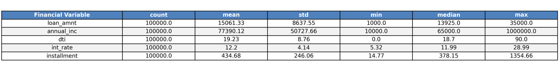
Table2. This table reports the number of observations (N), the mean, standard deviation (Std. dev.), minimum, median, and maximum for the primary financial variables used in the default prediction model.
  - Data Source Preprocessing
The data preparation process began with the loading of the raw Lending Club dataset, which included over 2.2 million records and 151 attributes.
We established a stringent data cleaning protocol to avert data leakage by omitting any variables that contained post-loan information, such as payment history, recovery amounts, or future-dated events that would not be accessible at the time of loan application.

Initially, the dataset was scrutinized for data quality issues, revealing invalid entries such as annual incomes below $10,000 or exceeding $1,000,000, unrealistic debt-to-income ratios surpassing 50%, and revolving utilization rates above 100%. These records were identified and removed to uphold the integrity of the analysis. The target variable was formulated by mapping loan statuses to binary outcomes: 'Fully Paid' as 0 (non-default) and 'Charged Off' as 1 (default), while excluding 'Current' loans and other statuses with indeterminate outcomes.

Furthermore, we performed feature selection to retain only those variables known at the time of application, discarding 15 potential leakage features that contained future information. Following this thorough cleaning process, a balanced sample of 100,000 complete loan records (50,000 defaults and 50,000 non-defaults) was extracted for modeling purposes. Categorical variables, including loan purpose, home ownership status, and credit grades, were encoded, and numerical variables were scaled to ensure optimal model performance. This refined dataset, along with its engineered features such as income-to-loan ratio and payment-to-income ratio, formed the basis for all subsequent default prediction modeling.
- Prediction model of loan default risk
In this section, we perform an extensive comparison of nine commonly utilized machine learning algorithms to determine the most effective model for evaluating loan default risk. The methods assessed include k-nearest neighbors (KNN), support vector machine (SVM), decision tree (DT), logistic regression, Gaussian naive Bayes (GauNB), and multilayer perceptron (MLP), among others.
  - Machine learning algorithms
In this research, we utilize a varied suite of machine learning algorithms to develop predictive models for loan defaults. The K-Nearest Neighbors (KNN) algorithm functions by locating the K most comparable loan records in the training dataset to a specific test sample and assigns a class based on a majority vote among these neighbors.

The Support Vector Machine (SVM) conducts classification by transforming the data into a high-dimensional space and identifying the optimal hyperplane that distinguishes defaulted loans from non-defaulted ones with the greatest margin.

The Decision Tree (DT) algorithm creates an interpretable model by recursively dividing the data based on feature thresholds to enhance predictive purity at each node.

Logistic Regression offers a probabilistic linear model, converting a linear combination of input features into a default probability through the sigmoid function.

Gaussian Naive Bayes (GNB) presumes conditional independence among features given the class label and utilizes Bayes' theorem to compute posterior probabilities under a Gaussian distribution.

The Multi-Layer Perceptron (MLP), a fundamental neural network, learns intricate non-linear relationships between borrower characteristics and default risk through multiple layers of interconnected neurons with non-linear activation functions.

Additionally, we apply various ensemble methods: Random Forest (RF) improves predictive accuracy and mitigates overfitting by aggregating predictions from numerous decorrelated decision trees; XGBoost, a gradient boosting framework, sequentially builds decision trees where each new model aims to rectify the errors of its predecessors; finally, Stacking merges the predictions of these diverse base models using a meta-learner to create a superior final prediction.

  - Model prediction performance
To evaluate the risk of loan default, we develop nine predictive models utilizing machine learning techniques, where the stacking model incorporates Random Forest (RF) and XGBoost as foundational estimators, with logistic regression serving as the concluding classifier.

To mitigate the class imbalance between default and non-default instances, we implement a random undersampling approach to equalize the dataset.

The results of the performance evaluation for these models are detailed in Table 3. Among these, the multilayer perceptron (MLP) attains the highest accuracy (67.65%), the highest AUC (0.7361), and the highest F1 score (0.4522), indicating its superior overall predictive performance. Conversely, the Random Forest model records the highest recall (68.46%), which is particularly significant in default prediction scenarios, where it is essential to identify as many defaults as possible. In contrast, the Gaussian Naïve Bayes model exhibits the least effective performance across all metrics.

While ensemble methods like stacking yield competitive outcomes, their computational expense is exceedingly high (approximately 7 hours of training time), rendering them less feasible compared to MLP or RF, which offer a more favorable balance between performance and efficiency.

To further investigate the influence and extent of each independent variable on default risk, we utilize the SHAP method to rank the importance of features for the Random Forest model. SHAP values deliver an additive interpretation of each feature’s contribution to the prediction outcome. The five most significant features identified are interest rate, loan term (60 and 36 months), and loan grade (A and B). These results underscore the substantial effect of loan characteristics on default risk.

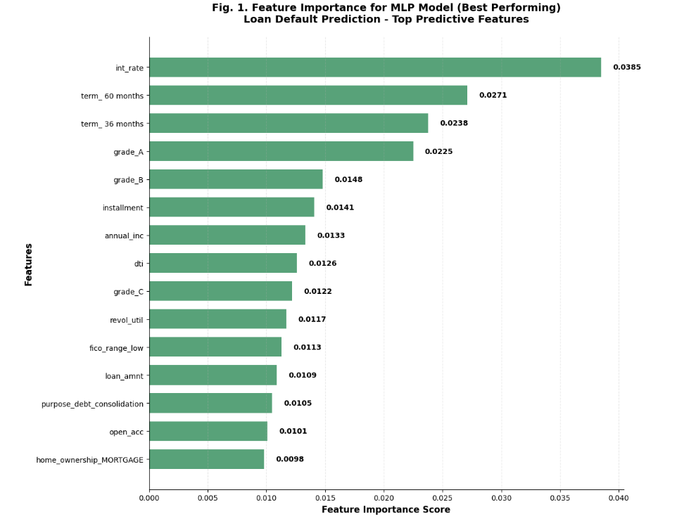

Table 3. This table presents the performance of nine machine learning models in predicting loan defaults, assessed through four metrics: accuracy, recall, AUC, and F1 score. Accuracy indicates the overall correctness, recall measures the proportion of accurately identified defaults, AUC demonstrates the overall discriminative ability, and the F1 score provides a balance between precision and recall. The leading two results for each metric are marked in red.

 | Accuracy (%) | Recall (%) | Precision (%) | AUC | F1
KNN | 63.96 | 62.70 | 30.49 | 0.68 | 0.41
SVM | 63.51 | 62.68 | 30.15 | 0.68 | 0.41
Logistic | 66.32 | 67.12 | 33.12 | 0.73 | 0.44
DT | 63.59 | 58.72 | 29.43 | 0.66 | 0.39
RF | 66.30 | 68.46 | 33.32 | 0.73 | 0.45
XGBoost | 66.42 | 66.97 | 33.17 | 0.73 | 0.44
Stacking | 66.72 | 67.57 | 33.52 | 0.73 | 0.45
GauNB | 59.34 | 54.23 | 25.60 | 0.59 | 0.35
MLP | 67.65 | 66.80 | 34.18 | 0.74 | 0.45

- Robustness Check: SHAP Value Validation of Financial Predictors

The previous sections have established that financial factors, namely interest rates, loan terms, credit grades, and debt-to-income ratios—act as significant indicators of the likelihood of loan default. The distribution of SHAP values for our Random Forest model offers strong validation of these conclusions, illustrating the relative significance and directional influence of each feature on default predictions.

As illustrated in the SHAP value plot, the interest rate (num_int_rate) stands out as the most significant predictor, with elevated values consistently raising the probability of default. Loan term features (cat_term_60 months and cat_term_36 months) are also prominent predictors, indicating that extended repayment periods heighten default risk. Credit grades (especially categories A, B, and D) exhibit considerable effects, with lower grades (D and E) markedly increasing the likelihood of default, while higher grades (A and B) provide protective benefits.

The analysis verifies that the debt-to-income ratio (num_dti), FICO score ranges (num_fico_range_low and num_fico_range_high), and income-to-loan ratios are essential indicators of financial health. Importantly, verification status and home ownership attributes also play a significant role in default predictions. The consistent directionality of these SHAP values across the ensemble model offers compelling evidence that the identified financial relationships are stable and dependable for forecasting loan default risk.

Fig. 2. Top nine features that have an impact on default prediction. Red (blue) represents high (low) feature values, that is, the numerical value of the predictor
is big (small)

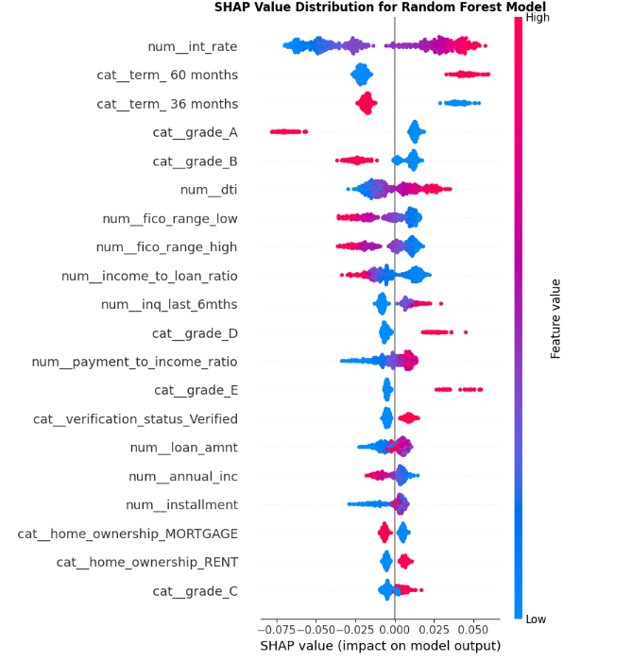

- Conclusions and future work
In this research, we utilized nine machine learning algorithms, such as support vector machine, decision tree, multilayer perceptron, random forest, and XGBoost, to assess default risk using data from Lending Club loans. Our analysis revealed that the Multilayer Perceptron (MLP) model exhibited the highest performance, achieving an accuracy of 67.65% and an AUC of 0.736, closely followed by Random Forest, which recorded the highest recall at 68.46%.

Through SHAP analysis, we determined that financial factors—especially interest rates, loan terms, credit grades, and income levels—are the most critical predictors of loan default risk, rather than demographic factors. In particular, elevated interest rates and extended loan terms significantly heighten the probability of default, while superior credit grades and increased income notably diminish default risk.

Our results offer valuable insights for financial institutions, illustrating that machine learning models combined with explainable AI techniques like SHAP can greatly improve risk assessment systems. The identified feature importance provides clear direction for loan underwriting decisions, facilitating more precise pricing strategies and enhanced portfolio risk management.

Future research should concentrate on several areas for optimization and improvement: First, hyperparameter tuning and advanced feature engineering could further enhance model performance beyond the current findings. Second, integrating temporal patterns and macroeconomic indicators could better capture the evolving dynamics of risk. Third, investigating deep learning architectures and ensemble methods may lead to additional predictive improvements. Fourth, evaluating these models on more recent and comprehensive datasets from various lending platforms would increase generalizability. Lastly, creating real-time monitoring systems that incorporate these machine learning techniques could offer continuous risk assessment and early warning capabilities for financial institutions.

References
[1] S. Albanesi and D. F. Vamossy, 'Predicting Consumer Default: A Deep Learning Approach', NBER Working Paper, no. 26165, Aug. 2019. [Online]. Available: https://www.nber.org/papers/w26165
[2] H. Li and W. Wu, 'The impact of financial technology on corporate innovation: Evidence from China', Finance Res. Lett., vol. 60, p. 104867, May 2024, doi: 10.1016/j.frl.2024.104867.
[3] M. Zięba, S. K. Tomczak and J. M. Tomczak, 'Ensemble boosted trees with synthetic features generation in application to bankruptcy prediction', Expert Syst. Appl., vol. 58, pp. 93-101, Oct. 2016, doi: 10.1016/j.eswa.2016.04.004.
[4] M. Djebali and W. B. Omri, 'Machine learning models for predicting credit risk: A comparative analysis of logistic regression and neural networks', J. Risk Financial Manag., vol. 16, no. 7, p. 312, Jun. 2023, doi: 10.3390/jrfm16070312.
[5] S. Malekipirbazari and V. Aksakalli, 'Risk assessment in social lending via random forests', Expert Syst. Appl., vol. 42, no. 10, pp. 4621-4631, Jun. 2015, doi: 10.1016/j.eswa.2015.02.001.
[6] I. K. Nti, A. F. Adekoya and B. A. Weyori, 'A comprehensive evaluation of ensemble learning for credit scoring', Neural Comput. Appl., vol. 33, pp. 13067-13089, Aug. 2021, doi: 10.1007/s00521-021-05948-1.
[7] Y. Wang, 'Loan default prediction using machine learning: A case study on the LendingClub platform', J. Finance Data Sci., vol. 8, pp. 1-15, Jan. 2022, doi: 10.1016/j.jfds.2022.01.001.
[8] C. L. Huang, M. C. Chen and C. J. Wang, 'Credit scoring with a data mining approach based on support vector machines', Expert Syst. Appl., vol. 33, no. 4, pp. 847-856, Nov. 2007, doi: 10.1016/j.eswa.2006.07.007.
[9] L. C. Thomas, 'A survey of credit and behavioural scoring: forecasting financial risk of lending to consumers', Int. J. Forecast., vol. 16, no. 2, pp. 149-172, Apr. 2000, doi: 10.1016/S0169-2070(00)00034-0.
[10] B. Baesens, T. Van Gestel, S. Viaene, M. Stepanova, J. Suykens and J. Vanthienen, 'Benchmarking state-of-the-art classification algorithms for credit scoring', J. Oper. Res. Soc., vol. 54, no. 6, pp. 627-635, Jun. 2003, doi: 10.1057/palgrave.jors.2601545.

